YouNG ONSET SUPPORT GROUP  Come along and join Nikki, Jenny, Alexis and Maja at the St George’s Young Onset Support Group.  We are having a very ‘Art’ based evening with news from Tash Clarke on her new St George’s Art and Dementia Project. Jacquie Nunn will join us to illustrate the benefits of Art Therapy via Arts4Dementia and Charlie Harrison from Created out of Mind will talk about his Artistic Research -Testing Situations - the 'Neva'  Cognitive Neurology Support Services  John Parker Lecture Theatre  Atkinson Morley Wing  St George’s Hospital  Tooting SW17 0QT  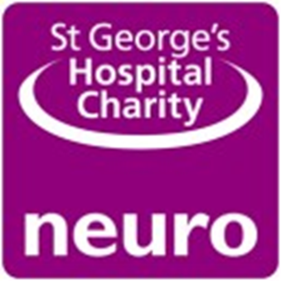 | Wednesday 29th May 6.30 -8.30pm  ────  A great opportunity to meet others living with young onset dementia and their families  ────  Get information and advice, share tips and coping strategies and have your questions answered  ────  Reduce isolation and feel supported  ────  Rsvp nikki@cog-neuro-support.com  07841 848909  This is a monthly support group  Street Address  City, ST ZIP Code  Telephone  Web Address  Dates and Times

