John Parker Lecture Theatre

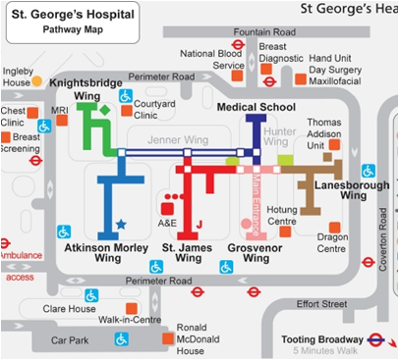

Support Group

HhhhHere